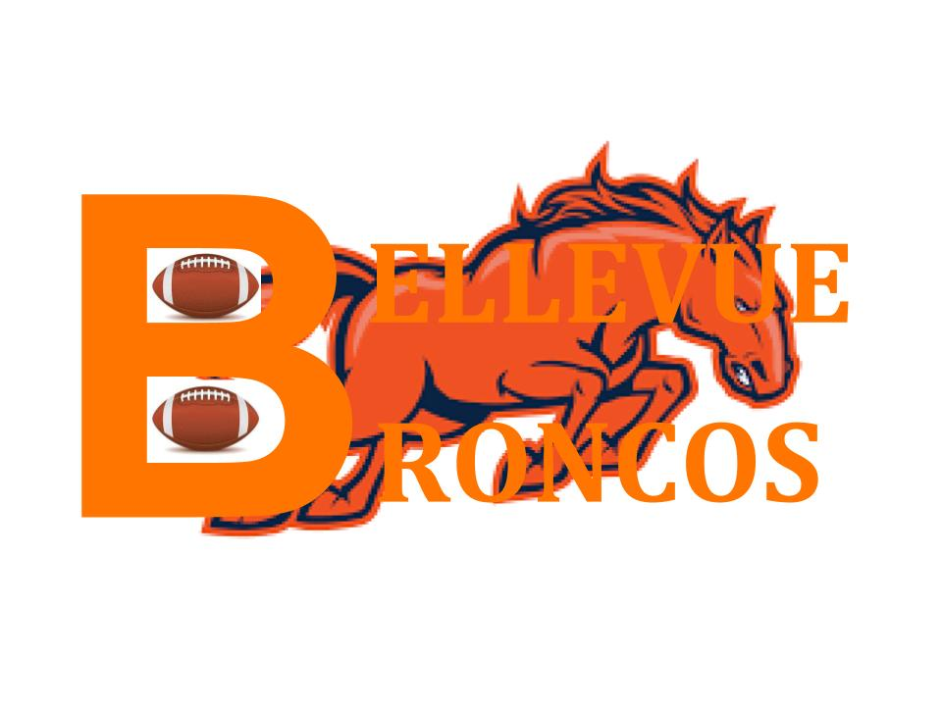

Broncos Indoor Training Facility
Estimated Training Equipment Inventory
Equipment type | Estimated Number Needed
Assortment of Pads | 25
Game Jerseys/Pants/Cleats/Gloves | 25
Practice Apparel | 25
Weight Bench | 12
Squat Rack | 10
Blocking Sleds | 4
Tackling Dummies | 6
Weight Sets | 22
Footballs | 50
Water Cooler | 3
Gatorade Cooler | 2

